

National University of Sciences and Technology Islamabad

**School of Mechanical and Manufacturing**

**Engineering**  
. **Fundamentals of Programming Lab**

**Mechanical Engineering 15**

**Section B**

**Assignment 4 FOP Lab**

**Submitted by:**

Muhammad Shahzeb Khan

**Registration #:**

479677

**Submitted to:**

Lab instructor Sir Saqib

**Due Date:**

25th October,2023

**Code 1:**

**Write code to show numbers to 150 except multiples of 10.**

#include<iostream>

using namespace std;

int main() {

int a=150;// declaring and specifying variables

cout<<”the numbers from 1 to 150 are”<<endl;

for(a=1;a<=150;a++)// applying for loop according to demand

{

if(a%10!=0)//applying if condition for getting numbers not divisible by 10

{

cout<<a<<”, “;

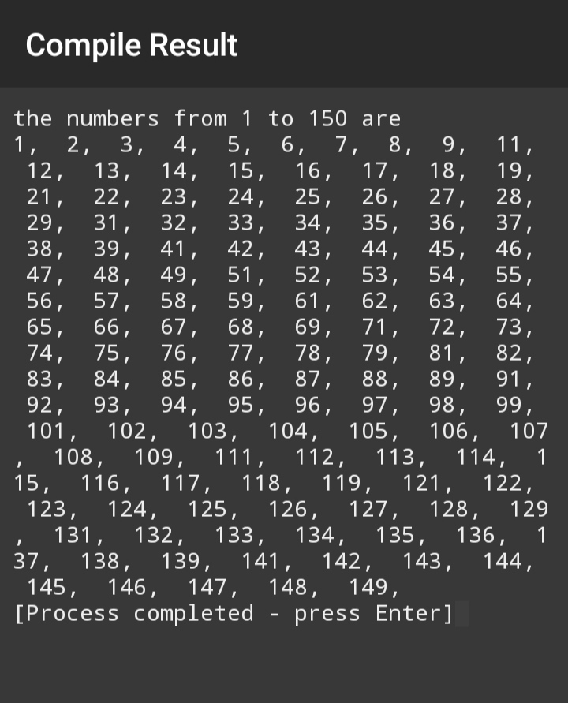 continue;}}}

**CODE 2:**

**Write code to show sum of digits of a number .**

#include<iostream>

using namespace std;

int main() {

int num;// declaration of variables

int sum=0;

cout<<”enter number whose digits are to be added”<<endl;

cin>>num;

while(num!=0)// applying while statement for required program

{ sum=sum+num%10;// giving expression for final result

num=int (num/10);// expression for division of num to get remainder

}

cout<<”the sum of digits of a number is”<<sum<<endl;

}

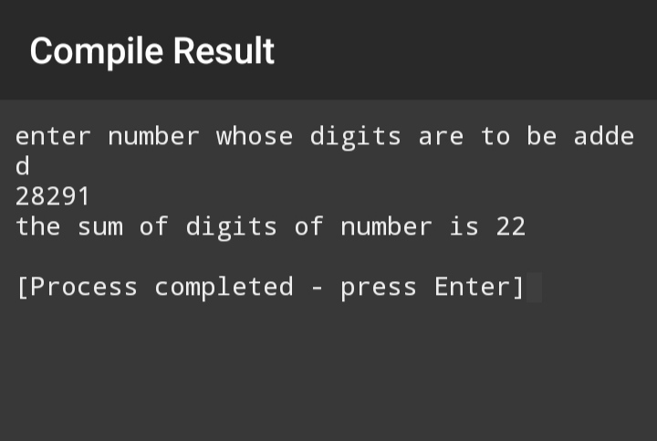

**Code3**:

**Write code to check number is prime number or not.**

#include<iostream>

using namespace std;

int main() { int num,I;// declaring variables

cout<<”enter number to be checked”<<endl;// demanding number which is to be checked

cin>>num;

i=2;// specified initial value of i

while(i<num)// applied while statement till a number less than original number

{

if(num%i==0)// applied if statement

{

cout<<”number is not a prime number”<<endl;

break;

}

i++;// increment

}

if(i==num)// applied another if statement

{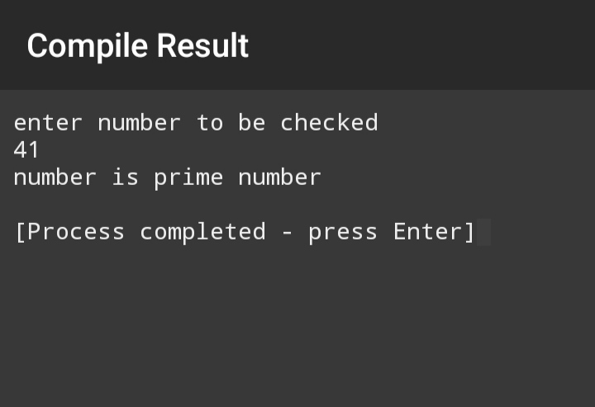cout<<”number is prime number”<<endl;} }